Snapshot of Uzbekistan’s 2022 IMRF Priorities and GCM Actionable Recommendations
Over the years, Uzbekistan has renewed and strengthened in numerous ways its commitment to the implementation, follow-up, and review of the Global Compact for Safe, Orderly, and Regular Migration (GCM). In the wake of the United Nation General Assembly’s endorsement of the Progress Declaration (A/RES/76/266), at the first ever International Migration Review Forum (IMRF), the GCM acquires yet more significance for international migration governance than ever before. The endorsement of the Progress Declaration places us at a critical crossroads, as it becomes increasingly important to ensure that we continue accelerating the implementation of the GCM while building on past achievements and establish forward-looking priorities on the basis of the IMRF’s milestone outcome document.
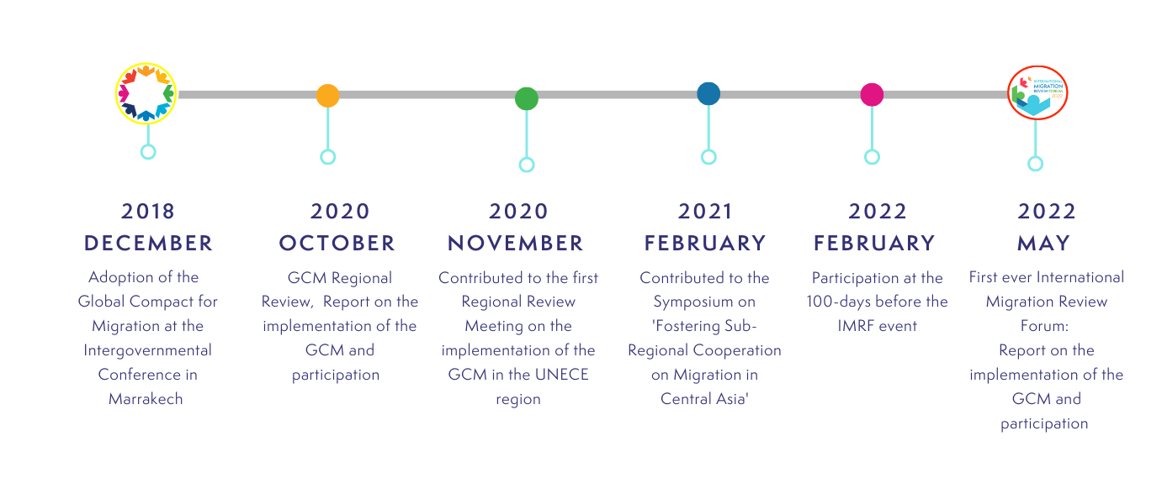
Some of Uzbekistan’s GCM milestones

In an effort to “breathe life into the Declaration’s text”, the following table provides a snapshot of the recommended actions to accelerate the implementation of the Global Compact and to strengthen international cooperation on international migration Member States presented through the Progress Declaration that IOM identified as priorities in Uzbekistan’s work to implement the GCM. The table intends to indicate the linkage between the recommended actions, the GCM and its complementary frameworks, including IOM’s Strategic vision, endorsed by IOM’s Member States.
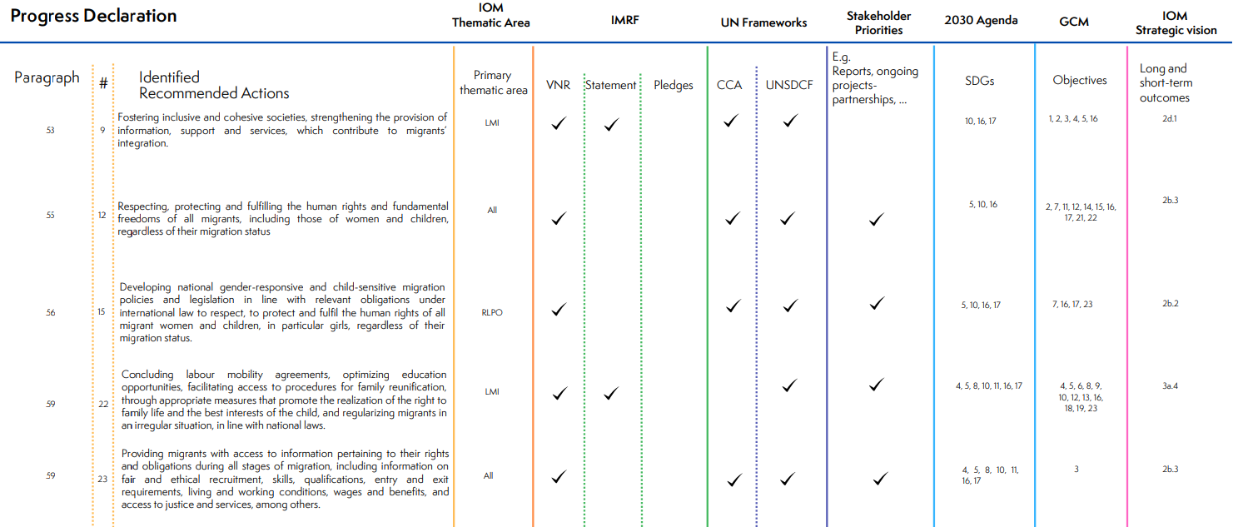
Actionable Recommendations
Based on the above priorities IOM identified in Uzbekistan’s national and UN frameworks, it is recommended IOM support the Government of Uzbekistan, among other things, with the following actions:
- In 2023-2024 IOM will continue assisting the Government of Uzbekistan, as well as NGOs, UNMN and UNCT, academia and private sector, as well as diaspora and migrants on strengthening their capacity on the actions of Progress Declaration of the International Migration Review Forum and encourage them to submit pledges and good practices jointly advocate for mainstreaming of the Global Compact in the national development agenda in line with a whole-of-government and whole-of-society approach by means of regular meetings with government representatives to share information and discuss the enactment of the Progress Declaration. (In line with Paragraph 71 of the Progress Declaration, Action 45)
- In 2023-2024 IOM will contribute to enhance national migration statistics capacity through capacity-building workshops on migration data collection in the context of labour migration for staff of the Ministry of Employment and Labour Relations, Agency for External Labour Migration, State Committee on Statistics and other relevant government entities to track, collect, register, disaggregate and analyse migration-related data and institutionalize migration data collection mechanism, in line with Paragraph 71 of the Progress Declaration (Action 45). The workshop is expected to take place in the first half of 2023 following the relevant study visits to learn a good foreign experience for the government staff organized by IOM.
- In 2023-2024 IOM will continue assisting the Government of Uzbekistan to jointly discuss issues and challenges related to labour migration trends with the Governments of country of destination for Uzbek labour migrants through facilitation of mutual discussions between relevant government entities of the countries in line with paragraph 59 of the Progress Declaration (Action 22)
- In 2023-2024 IOM will continue its previous efforts to assist the Government of Uzbekistan on combatting trafficking in persons in order to protect and fulfil their human rights and fundamental freedoms in line with Paragraph 55 of the Progress Declaration (Action 12). IOM will enhance the relevant government entities and NGO’s capacity on identification and referral of victims through a series of trainings for the staff of regional branches of National CTIP Commission, Agency of social and medical services and relevant NGOs. The trainings are expected to take place in the mid of 2033 and delivered by high experienced experts hired by IOM.
- In 2023-2024 IOM will continue its efforts to provide migrants with access to information pertaining to their rights and obligations during all stages of migration, including information on fair and ethical recruitment, skills, qualifications, entry and exit requirements, living and working conditions, wages and benefits, and access to justice and services, among others in line with Paragraph 59 of the Progress Declaration (Action 23). IOM will community outreach and awareness raising activities by involving local NGOs and through disseminating information materials as well as conducting regular info sessions among migrants regardless of their status.

The Progress Declaration’s Recommended Actions identified as priorities were selected according to the following criteria:
- The highest number of references across national UN, governmental and stakeholder frameworks, which is obtained by filtering the last column of Uzbekistan’s tab (here)
- A balanced representation of thematic areas/units across the most referenced Recommended Actions
These priorities are not exclusive as there are additional areas of focus emerging from this national analysis. For a comprehensive overview of national priorities, please see Uzbekistan’s tab: here

Given the relevance of this tool for resource mobilization purposes, IOM RO Vienna is currently mapping the Progress Declaration’s Recommended Actions against donors’ priorities

Remarks of Abdulla Shahid, President of the 76th session of the UN General Assembly and chair of the International Migration Review Forum. Full speech here.

