A Call to Local Action for Migrants and Refugees
STEP 2: LOCAL ACTION SUBMISSION FORM
Thank you for your interest in joining the Call to Local Action for Migrants and Refugees.
Please note that filling out this form will take an approximate time of 20 minutes.
The Mayors Mechanism Steering Committee members United Cities and Local Governments (UCLG), the Mayors Migration Council (MMC), and the UN Migration Agency (IOM), in partnership with the UN Refugee Agency (UNHCR), are launching a “Call to Local Action for Migrants and Refugees”, with the objective to:
- Expand the number of Local and Regional Governments (LRGs) publicly endorsing the Compacts through the Marrakech Mayors Declaration and showcase growing public leadership and political will.
- Collect and showcase the bold, people-centred local actions that achieve or exceed the Compacts’ goals to facilitate cross-fertilisation, peer learning, and replication by other LRGs.
- Ceate a cohort of publicly recognized local and regional leaders engaged in robust GCM and GCR implementation to motivate scaling and investment in local and regional practices by States, and form new partnerships with international actors.
The basis of this call is to support the Marrakech Mayors Declaration, endorsed by mayors and local government executives in 2018. The declaration calls for the full and formal recognition of the transformative role that local and regional governments play in the implementation of the Global Compact for Safe, Orderly and Regular Migration (GCM) and the Global Compact on Refugees (GCR) and their engagement to fulfil both compacts in unison. These frameworks are rooted in and provide a path for achieving the 2030 Agenda for Sustainable Development by ensuring rights-based migration and forced displacement governance.
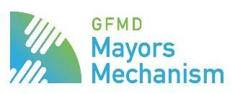
The Mayors Mechanism is a partnership jointly steered by:
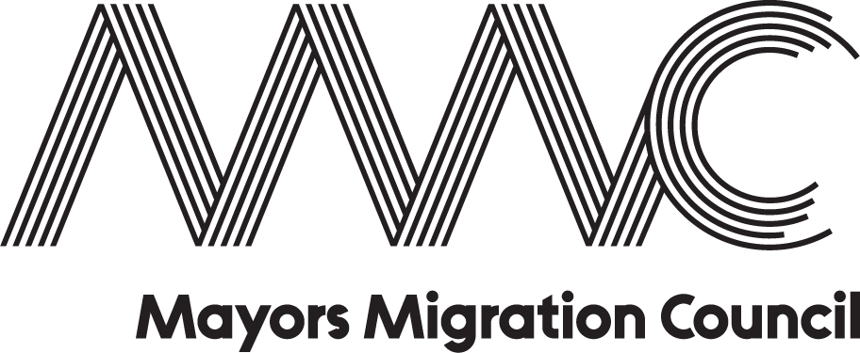
The Call to Local Action for Migrants and Refugees is also supported by:
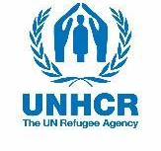

Important notes:

By submitting an action, you agree that your activity will be included in the Mayors Mechanism Annual Flagship Publication and website. The Mayors Mechanism will help Local and Regional governments get access to official GCM and GCR platforms, as well as the GCR pledging process and the GCM pledging process (in development).

The Mayors Mechanism will share the submitted actions with the following platforms:
- GCM Practices Repository - UN Network on Migration Hub.
- GCM Pledging Platform
- GCR Good practices & Innovative approaches | WithRefugees (unhcr.org)
- GCR Pledging Platform - UNHCR GCR Digital Platform.
- Global Forum on Migration and Development (GFMD) - Platform for Partnerships.
- UN Migration Agency Migration for Development project map.

Local and regional governments are encouraged to make contributions that are new or additional, which also could include strengthening and building upon good practices or ongoing activities.

Note that only activities that have a continuing commitment will be submitted to the UNHCR GCR Digital Platform. Only practices that directly address refugees, internally displaced persons and stateless persons will be submitted to the UNHCR GCR digital platforms.

If comments or questions, do reach out to: cta@mayorsmechanism.org

Step 1: Before you submit your Action
1. Do you have explicit authorisation as an appointed Technical Staff by your mayor, county executive, equivalent or member of the parliament with mandate over migration and/or displacement to submit your action to this Call for Local Action?
☒ Yes
2. Did your mayor, county executive, equivalent or member of the parliament with mandate over migration and/or displacement endorse the Marrakech Mayors Declaration?
☒ Yes
☐ No
☐ I don’t know
3. Name of the appointed Technical Staff responsible for this submission
Corinne Huybers

4.Contact email address
Corinne.huybers@mechelen.be
5. Type of local or regional government you represent
Municipality ☐ Other (please specify): Click or tap here to enter text.
6. Name of your local or regional government
Mechelen
7. Country
Belgium
8. Name of your Mayor, equivalent Executive Government Official or Parliamentarian responsible for migration and displacement
Alexander Vandersmissen (mayor), Gabriella de Francesco (alderwoman authorized for Diversity) & Abdrahman Labsir (alderman authorized for Youth Work)
9. Have you been invited by your national government to contribute to discussions about national implementation and review of the GCM and/or the GCR?
☒ Yes, please elaborate: Mechelen will join the delegation of the Belgian government to the IMRF in New York.
☐ No
10. Have you been invited by an intergovernmental organisation (e.g., EU, AU, Mercosur, etc.) to contribute to discussions about regional implementation and review of the GCM and/or the GCR?
☐ Yes, please elaborate: Click or tap here to enter text.
☒ No
11. Are you interested to showcase your local or regional government’s actions, challenges and successes at the International Migration Review Forum in May 2022?
☒ Yes
☐ No
12. Are you interested to pledge your local or regional government’s actions, and/or highlight challenges and successes at the Global Refugee Forum in December 2023?
☒ Yes
☐ No

Step 2: Submit your Action
13. Name of a contact person linked to the project
Jolan Rooze
14. Their position
Youth consultant at youth service (Leisure Department)
15. Their email address
jolan.rooze@mechelen.be
16. Name of the action (120 characters max.)
Youth Work for All
17. Type of action
Project / programme
18. Brief description, including principal objectives (max 200 words)
Not every family finds its way easily to youth work. The youth movements of Mechelen are not yet a reflection and representation of the diversity in our city. The youth service has taken up the challenge to change this with the youth movements and their associations. The project aims at: families (children, youngsters, parents) with a migration background and/or a refugee story (aim of guiding children/youngsters to youthwork); and youth movements (strengthening these organisations (and by extension youth associations) in order to reach the above-mentioned target groups more easily, and support them in setting up a diversity policy). The main objectives of the project are: guiding new members with a migration background sustainable towards youthwork; supporting associations regarding diversity, inclusion & accessibility; and raising awareness of the added value of youthwork.
19. Website
https://www.mechelen.be/jeugdwerk-voor-alleman
20. Start and end of implementation
Start (if a future action, enter estimated start date):
01/03/2021 Click or tap to enter a date.
End (if ongoing, leave blank or estimated end date):
28/02/2023 Click or tap to enter a date.
21. Is your action implemented in partnership with others?
☒ Yes
☐ No
22. If yes, please tell us what type of partners and their names
☐ National Governments: Click or tap here to enter text.
☐ Migrant, stateless persons, IDP or refugee-led organisations: Click or tap here to enter text.
☐ Host communities
☐ Diaspora organisations: Click or tap here to enter text.
☐ Private sector: Click or tap here to enter text.
☐ International organisation: Click or tap here to enter text.
☒ Civil society organisations: Click or tap here to enter text.
☒ Local or regional government administration: Click or tap here to enter text.
☐ Local or regional government network: Click or tap here to enter text.
☐ Academics and researchers: Click or tap here to enter text.
☐ Parliament: Click or tap here to enter text.
☐ Sports organisation: Click or tap here to enter text.
☒ Other: youth movements
23. Please tell us what type of beneficiaries and their names
☐ National Governments: Click or tap here to enter text.
☒ Migrants
☒ Refugees
☐ Internally Displaced People (IDPs)
☐ Stateless Persons
☐ Host Communities
☐ Diaspora Organisations: Click or tap here to enter text.
☐ Private sector: Click or tap here to enter text.
☐ International organisation: Click or tap here to enter text.
☐ Civil society organisation: Click or tap here to enter text.
☐ Faith-based organisation: Click or tap here to enter text.
☒ Cities, municipalities and local authorities: Click or tap here to enter text.
☐ Academics and researchers: Click or tap here to enter text.
☐ Sports organisation: Click or tap here to enter text.
☒ Other: youth movements
24. What is the expected/achieved impact of your action, and how will/have you evaluate(d) it (max 300 words)?
1) Youth work as a safe space: Youth organisations have been strengthened in terms of accessibility and diversity by organizing training, networking moments; by 24 individual interviews with youth movements; all 24 youth movements have a "youth work for label"; annually we offer 5 intensive (diversity/inclusive) counselling processes for youth movements. 2) Sustainable guidance of children and young people with a migration background to youth work in Mechelen: Recruitment of 60 children and young people with a migration background and/or a refugee story as participant/leader; and 100 home visits (on average 1 per week). 3) Image creation and perception: Parents, children and young people have a better idea of youth work and recognise the added value and richness of it; bij organizing focusgroups with youngsters, volunteers, parents, professionals and employers; development of educational material (videos); collect and share minimum 15 testimonies on storytelling platform; and by organising yearly "warm welcome (CHILL) days". We foresee a regular staff deployment by the youth service and J@m vzw, and in addition a secondment of Group INTRO vzw in close cooperation with the youth service and J@m vzw so that we can bring in Group INTRO vzw's expertise with regard to children and youngsters with a migration background (and refugee story) into the respective workings. We pay attention to the entire operation of the youth service and evaluate the experiences made. The co-financing ensures more shared leadership and shared involvement, commitment and ownership. It ensures that we build expertise, and can embed it in existing services. The ambition of shared ownership and expertise building is also reflected in the financial proposal: the city provides co-financing. We focus on the positive learning experiences of young people and the long-term impact. In addition, we continue to build up a framework for youth work and scale it up through supra-local exchange.
25. (not applicable for future actions) What are the key lessons learned from your action so far (max 300 words)? Please elaborate.
The Project staff members (seconded from J@m vzw & Groep Intro vzw) are embedded within the youth service. This creates the necessary synergy (working on diversity from the inside). With the "Youth Work for All" project, all the knowledge and experience that has been present at various levels for years is bundled into one project in which all the partners participate and take an active role. This knowledge and experience is also translated into immediately usable toolkits and methodologies, as a result of which the results will also be immediately noticeable and will inspire others. The emergence of new networks and new partnerships. The "Youth Work for All" project works with a label (10 point action plan), rewarding the youth work initiatives involved for their efforts. The youth movements receive professional support in various forms (tailor made, generic trainings, toolkit, etc.) to realise the 10 point actionplan. Monitoring & evaluation of these action plans and professional support is crucial. Pitfalls/challenges: A sense of urgency among the youth movements versus a lack of capacity (members stop) of youth movements. Sustainable embedding of the project within the regular activities of the youth service & J@m vzw (need of structural resources & personnel). Follow-up and monitoring of the action plans and therefore the labels “Youth Work for All” is necessary. Youth movements are a special form of voluntary organization that cannot be compared to cultural or sports associations. Every three years there is a completely new leadership team consisting almost exclusively of young people who do this on a voluntary basis. The leaders often change their composition, so that knowledge and commitments are lost in the long term. Anchoring initiatives as 'Youth Work for All' in their operation will therefore take time and energy.
26. In the “Marrakech Mayors Declaration”, local and regional governments commit to advance several priority objectives. Please indicate up to five (5) priorities your action contributes to
☐ | Improving local migration and forced displacement governance |  |  | Minimising the drivers of forced migration and displacement | ☐
☐ | Protecting those most vulnerable | 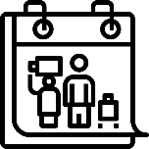 |  | Providing access to urban infrastructure, social services, and education regardless of status | ☐
☒ | Realising social inclusion |  |  | Eliminating all forms of discrimination and promote evidence-based public discourse | ☒
☒ | Supporting reception and advance community sponsorship initiatives |  |  | Engaging in regional and multilateral partnerships and increase city-to-city cooperation | ☐

27. As we are designing our peer-learning strategy, are there specific topics you would like to learn more about?
Eliminating all forms of discrimination and promote evidence-based public discourse
Other: measuring the impact of our initiatives/strategies

To submit another action please make a copy of this file and change the name accordingly changing the last number in “MM_CTA_FORM_CITY_001”, you will only need to fill out Step 2: Submit Your Action again.

Optional information
28. Size of the population served by your local or regional government
24,1% of the population of Mechelen is < 19 years. In total we are talking about more or less 20.000 children and youngsters. More then 50% of the children < 12 years have a migration background.
29. What is the funding, financial and in-kind, dedicated to the action? Kindly state the local currency
More than U$S 50.000
Would you like to specify? 140.000 euro
30. In order to bolster visibility of you action, please submit with this form the following:
- a picture of the project to accompany your submission on the website (.jpg, .jpeg, .png)
- 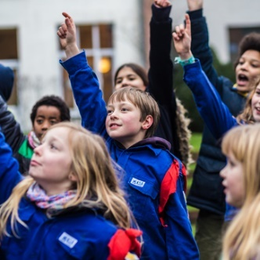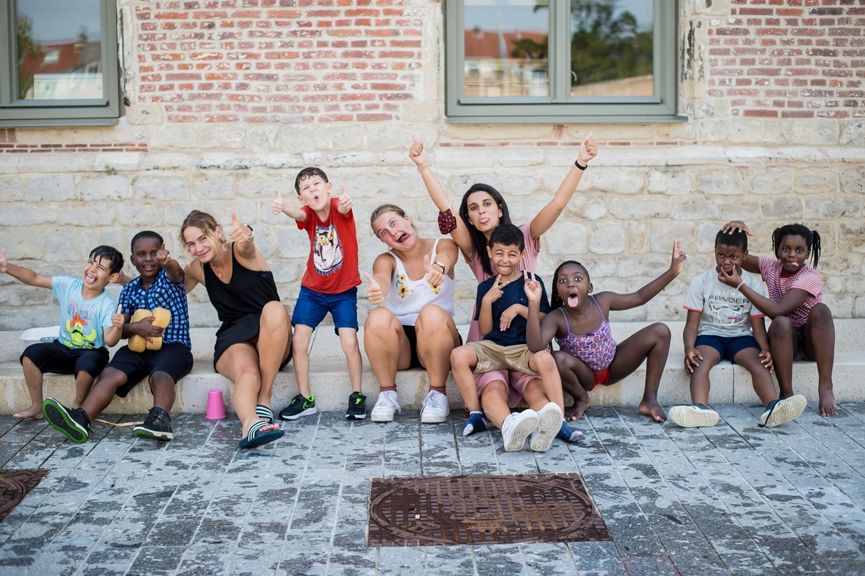
- a picture of your Mayor or Executive Government Official (.jpg, .jpeg, .png)

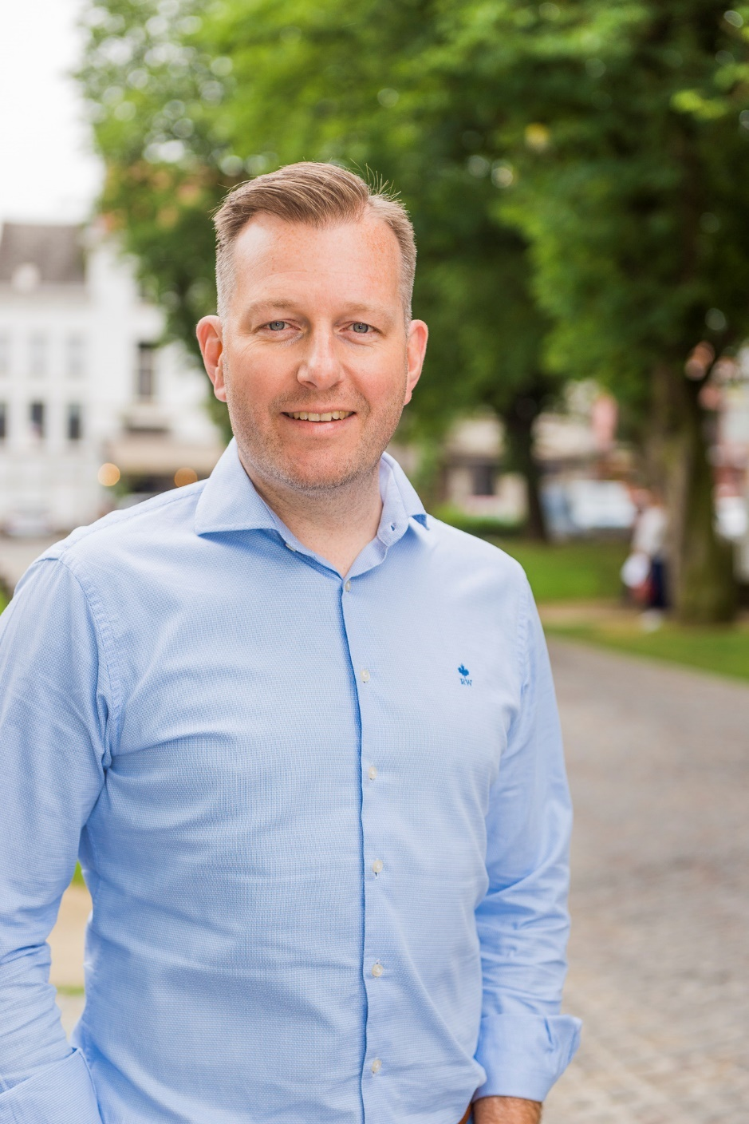
(mayor, Alexander)

(alderwoman, Gabriella)

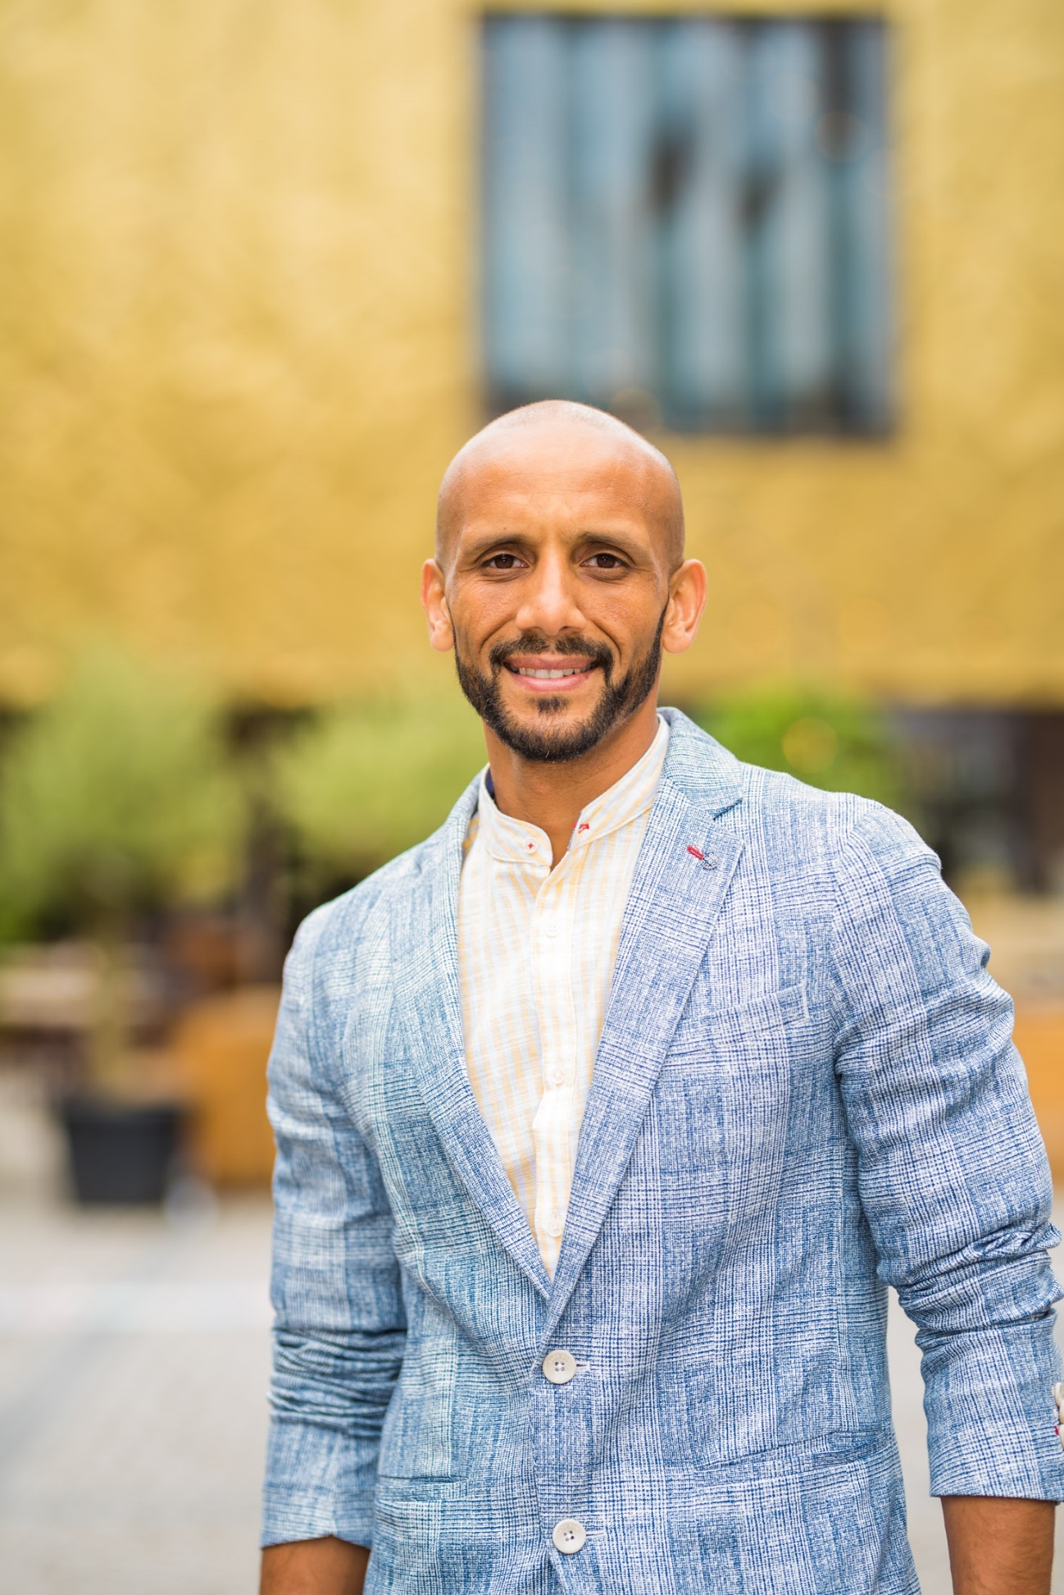
(alderman, Abdrahman)

- If available, a pamphlet or longer description of the action (.pdf, .jpg, .jpeg, .png)

- a quote of your Mayor or Executive Government Official (max 2 sentences) to accompany your submission on the website
"The cooperation within Youth Work for All is complementary, partners complement each other's expertise nicely, but will also learn from each other during the project.” (quote form Alderman Abdrahman Labsir) "In the next 2.5 years, we will focus specifically on children and young people with a refugee story. This is an objective that we in Mechelen have put on the agenda as a priority for this term of office. Our youth movements are already a second home for many children and young people where friendships for life are forged. Together with our youth movements, we also want to offer children on the run a warm welcome." (quote from Alderwoman Gabriella De Francesco.

